

Optimizing Montreal's Réseau Express Vélo Expansion:
A Three-Phase Approach to Corridor Discovery, Budget Allocation, and Construction Sequencing
Fall 2025 - MGSC-662-076 Decision Analytics
Instructor: Professor Javad Nasiry

Group 5
Faye Wu (261043794)
Maral Vahedi (261231293)
Tia Qiu (261004373)
Helia Mahmood Zadeh (261224416)
Fares Joni (261254593)

December 3rd 2025

Introduction
Montreal, Canada’s second-largest metropolitan region, has made substantial commitments to sustainable mobility. A central component of this effort is the Réseau Express Vélo (REV), a planned network of wide, fully protected cycling corridors intended to replace the city’s patchwork of traditional bike lanes with a fast, continuous, and reliable system. Unlike narrow or mixed-traffic bike lanes, REV corridors follow strict design standards emphasizing safety, directness, and year-round maintenance, positioning them as high-capacity mobility infrastructure rather than incremental street improvements. Despite this ambition, the REV remains largely incomplete. Only 24 km of REV-standard corridors have been built, leaving most planned segments unconnected and creating isolated “islands” of high-quality infrastructure. Fragmentation, slow multi-year construction timelines, and seasonal constraints limit the network’s usability and contribute to perceptions of underuse not because demand is low, but because the system is not yet functionally continuous.
Demand indicators, in contrast, show clear and growing interest in cycling. In 2024, BIXI recorded 13 million trips, including nearly one million winter trips, demonstrating strong willingness for year-round active travel (CityNews, 2024). Yet cycling accounts for just 2.83% of utilitarian trips, despite 36.4% of residents biking at least once weekly (Rodrigue et al., 2023). This mismatch highlights substantial latent demand that the current fragmented network cannot fully support. This tension between rising demand and incomplete infrastructure defines the core challenge motivating our project: How should Montreal prioritize and sequence REV corridor construction to maximize mobility impact under real-world constraints? The city must determine not only which corridors to build, but in what order, given budget limitations, geography, overlapping segments, and seasonal construction feasibility.
Our project develops a data-driven, optimization-based framework to guide REV expansion. Using spatial clustering to identify corridor candidates, integer linear programming for selecting an optimal subset, and time-aware scheduling to sequence construction, we propose a plan that maximizes accessibility, reduces fragmentation, and accelerates meaningful network connectivity. More broadly, this work demonstrates how analytical tools can inform large-scale infrastructure planning and help Montreal advance its sustainable transportation goals more effectively.

Problem Description
The expansion of Montreal’s Réseau Express Vélo (REV) faces four structural pain points that limit the network’s effectiveness and slow progress toward the city’s cycling and sustainability goals.
Pain point #1 Fragmentation of Existing and Planned Corridors: Although Montreal’s cycling network exceeds 700 km, studies show that it remains poorly connected and unevenly distributed across neighbourhoods. Protected and separated lanes are particularly limited in length and are often fragmented, forcing cyclists to take longer trips to remain on comfortable infrastructure. As a result, the current REV network functions as isolated segments rather than continuous corridors, reducing usability and limiting the impact of new investments (Rodrigue et al., 2023).

Pain point #2 Winter Access Limitations: Research shows the winter cycling network is more concentrated in central neighborhoods and accessibility issues increase in winter (Carpentier-Laberge et al., 2024). While REV lanes are plowed, some key routes like portions of the Lachine Canal remain unplowed, limiting year-round usability (2727 Coworking, 2025).

Pain point #3 Supply–Demand Mismatch: Cycling interest far exceeds cycling infrastructure. Although 36.4% of Montrealers bike weekly, only 2.83% of all utilitarian trips are made by bike (Rodrigue et al., 2023). BIXI trip data shows that demand is highly concentrated on certain corridors, yet infrastructure is not aligned with these flows. Only 10.7% of high-potential roads have good infrastructure, and many high-demand areas remain underserved (Prince et al., 2025).

Pain point #4 Construction Delays and Political Uncertainty: The REV rollout has progressed slowly and inconsistently. Only a small portion of the planned corridors have been installed to date weakening public confidence and reducing the early value of the network (Feith, 2025). Construction is constrained by winter conditions, limited crew capacity, and shifting political signals causing delays that further limit corridor usability.

Based on those four pain points, the Montreal REV expansion project faces a complex optimization challenge with multiple competing objectives and constraints:
Network Fragmentation Problem: Montreal's candidate cycling infrastructure comprises 8,899 potential segments dispersed across the city. However, existing REV infrastructure (24 km) already occupies space in the street network. When expanding the REV, we must avoid duplicating existing protected lanes.

Linear Continuity Requirement: Simply selecting scattered segments does not create usable infrastructure. Cyclists require navigable paths composed of continuous, connected segments that together form coherent corridors. The challenge is not just identifying high-demand segments, but assembling them into realistic, contiguous riding routes.

Demand-Supply Misalignment: Current infrastructure does not prioritize high-demand routes. The problem requires identifying which linear paths, when selected and constructed together, will maximize impact on cycling mode share while respecting budget and temporal constraints.

Construction Sequencing: With a REV’s multi-year (2020-2031) implementation timeline and limited resources, the project must determine optimal phasing to minimize total project duration while maintaining operational capacity constraints.

2.1. Project Objectives
This research aims to identify an optimal set of bicycle corridor investments within Montreal's remaining $186 million REV (Réseau Express Vélo) budget, derived proportionally from the city's total $214 million allocation for the planned 184-kilometer network during 2020-2031 (Rodrigue et al., 2023). The primary objective is to maximize BIXI ridership demand served through strategic corridor selection while ensuring budgetary feasibility and network coherence.
The study addresses several critical urban mobility challenges through interconnected analytical objectives. First, it seeks to resolve network fragmentation by identifying and prioritizing continuous, navigable corridor sequences that form connected geographic spines rather than isolated segments, thereby enhancing overall network utility and connectivity. Second, it incorporates redundancy avoidance by systematically excluding segments already protected within the existing REV infrastructure, ensuring efficient allocation of limited resources to unmet demand areas.

A demand-responsive approach guides corridor selection through the integration of empirical BIXI trip data, directly addressing the observed demand-supply gap by targeting investments toward areas with demonstrated cyclist activity patterns. Additionally, the research incorporates seasonal optimization to minimize total construction duration through strategic scheduling that accounts for Montreal's climatic constraints, particularly reduced winter productivity. Finally, the methodology respects municipal implementation capacity by acknowledging administrative and permitting limitations through constraints on simultaneous project initiation, ensuring the proposed construction schedule aligns with realistic operational capabilities.

2.2 Our Three-Phase Approach
To transform this granular street-level data into an actionable REV expansion plan, we employ a three-phase optimization pipeline, which mirrors real-world planning:
- Phase 1 – Corridor Discovery: Convert thousands of disjoint segments into a structured set of continuous, directionally coherent corridor candidates. This acts as preparation.
- Phase 2 – Corridor Selection: Use integer linear programming (ILP) to select the optimal set of corridors that maximize BIXI demand subject to budget, overlap, and minimum-length constraints.
- Phase 3 – Construction Scheduling: Apply mixed-integer programming (MIP) to assign construction start times under seasonal and resource limitations to minimize total project duration.

3. 3-Phases Funnel Approach Methodology – Formulation, Result, and Interpretations

3.1. Phase 1: Corridor Discovery via Linear Path Extraction
The analytical process begins with a dataset of 8,899 candidate street segments (originally identified through OpenStreetMap data, traffic analysis, and urban planning studies), each represented as a LineString geometry with associated attributes such as length, construction cost, and estimated BIXI demand (See Appendix A for data source information). All geometries are projected into EPSG:3857, and 441 segments overlapping the existing REV network are removed to avoid redundancy, leaving 8,248 expansion candidates. These segments are then converted into a directed connectivity graph, where segment endpoints serve as nodes and segments as edges, producing 7,841 nodes and 8,214 edges. Using depth-first search (DFS), we identify connected components to ensure that only physically contiguous segments those cyclists can traverse without interruption are considered for corridor formation.
To establish viable cycling corridors, street segments must be consolidated into continuous, navigable linear sequences. This is achieved through linear path extraction, which identifies maximal connected routes within each network component while ensuring real-world usability. A valid linear path is defined as a unique sequence of segments traversed exactly once, maintaining directional coherence within a ±15° angular threshold relative to the mean orientation, and representing the longest possible extension without violating these geometric and topological constraints. Segment direction vectors are compared to the path’s mean heading to enforce collinearity (See Appendix B.1 for result).
This process (See Appendix C for detailed explanation) yields a refined set of candidate corridors with aggregated length, cost, and demand. Only corridors ≥ 3 km are retained to avoid fragmentation issues and ensure meaningful contributions to network connectivity. These corridors form the decision units used in Phases 2 and 3 for corridor selection and construction scheduling.

3.2. Phase 2: Corridor Selection via Integer Linear Programming (ILP)

3.2.1. Phase 2: Mathematical Formulation
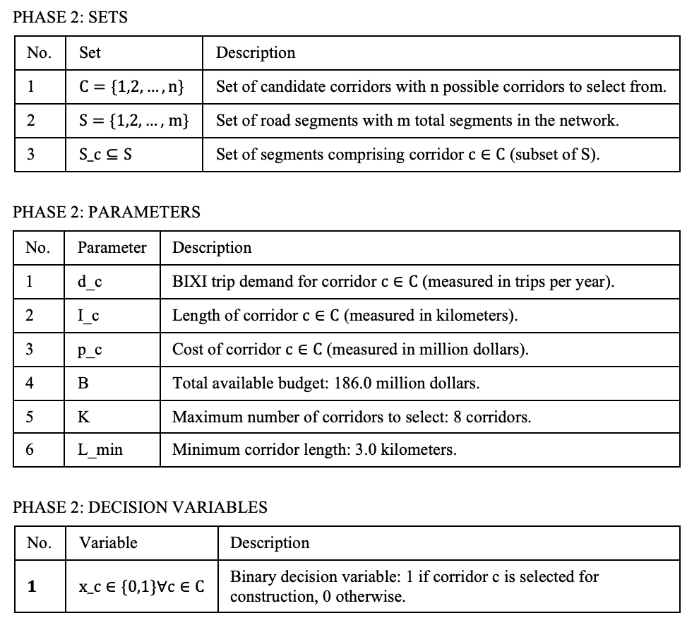
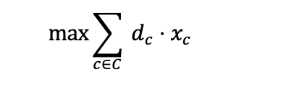
Objective Function: Maximize total BIXI trip demand:

Constraints:
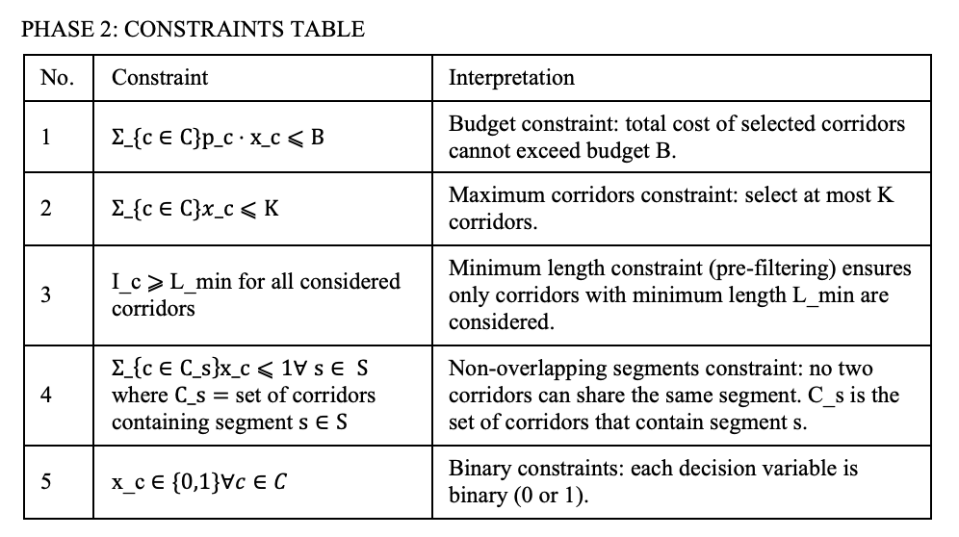
Additional Implementation Details:
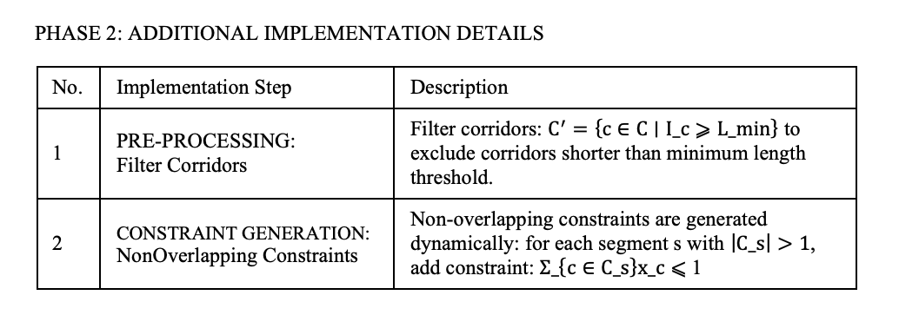
Output metrics:
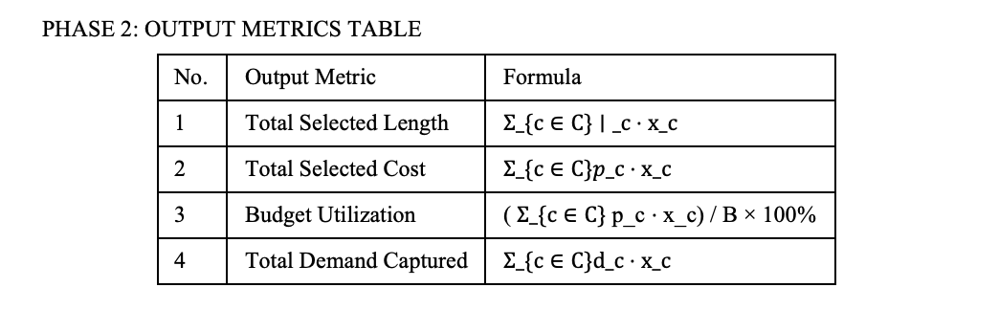

This formulation represents a maximum coverage problem with budget and non-overlap constraints. The objective maximizes demand coverage while respecting budget limits, capacity constraints, and ensuring that selected corridors don't share road segments.

3.2.2. Phase 2: Result
Table 3.2.2.1. Selected Corridor Result Data Summary
Corridor ID | Length (km) | Cost ($M) | BIXI Trips
21 | 47.08 | 101.77 | 131146
23 | 23.75 | 34.47 | 369010
31 | 5.46 | 11.98 | 78272
36 | 3.48 | 3.72 | 8439
40 | 3.66 | 6.00 | 237347
41 | 3.25 | 8.33 | 298860
59 | 3.50 | 10.68 | 109380
75 | 3.69 | 7.83 | 147176
TOTAL | 93.88 | 184.77 | 1379630
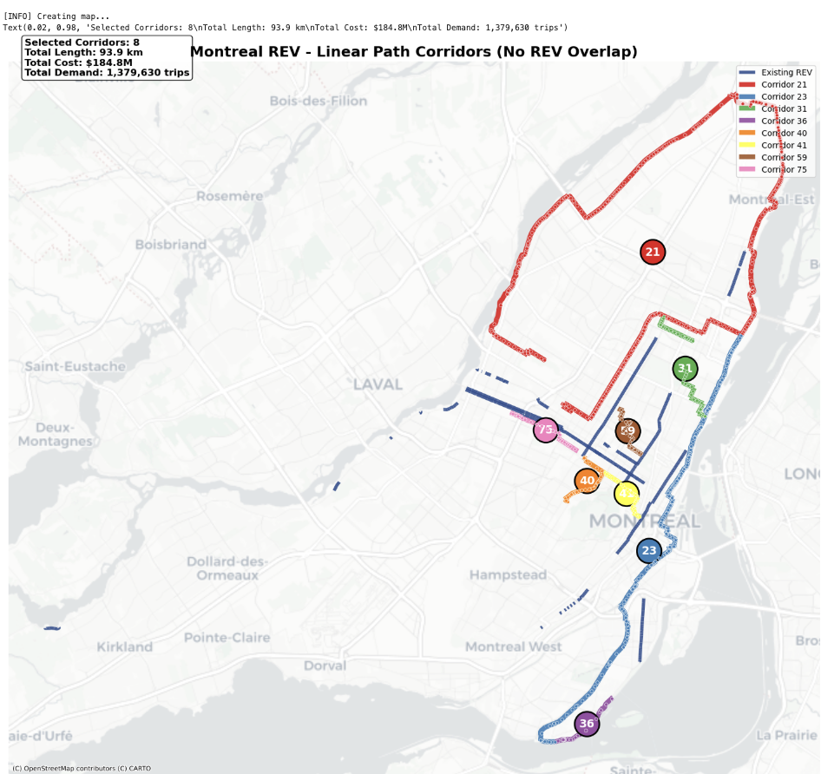
Figure 3.2.2.2. Geographic Visualization of Selected Corridors

3.2.3. Phase 2 Interpretation
The Phase 2 ILP model selected 8 corridors totaling 93.88 km at a cost of $184.77M, utilizing 99.3% of the available budget to serve 1.38 million daily BIXI trips. The solution demonstrates both mathematical optimality and strong alignment with real-world urban cycling dynamics. High-demand corridors such as 23, 41, and 40 were prioritized, effectively targeting existing cyclist flows to address supply–demand gaps while maintaining cost efficiency by selecting routes that deliver strong ridership impact per dollar invested.
Furthermore, the model successfully enforced continuity and non-redundancy constraints, yielding long, navigable corridors that form coherent geographic spines rather than fragmented segments. The exclusion of certain viable but overlapping or lower-impact corridors underscores the solution’s adherence to practical construction and network coherence requirements. Collectively, these outcomes reflect a realistic, buildable network plan that balances demand, budget, spatial feasibility, and Montreal’s broader mobility objectives.

3.3. Phase 3: Construction Team Optimization for REV Network Expansion

3.3.1. Phase 3: Mathematical Formulation
The construction phase involves implementing eight bicycle corridors in Montreal, with lengths ranging from 3.3 km to 47.1 km, subject to several operational constraints: a maximum of two new projects may commence per quarter, seasonal productivity varies significantly (Summer: +20%, Winter: -40%), and multiple construction teams can be assigned concurrently to a single corridor. The objective is to minimize both total project completion time and the number of construction teams required, balancing speed, resource efficiency, and practical scheduling limitations.
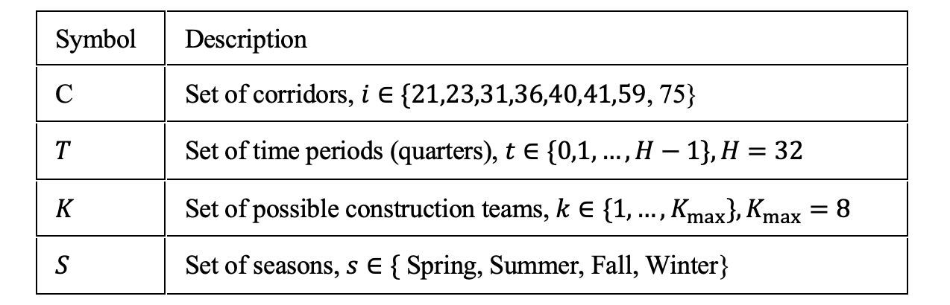
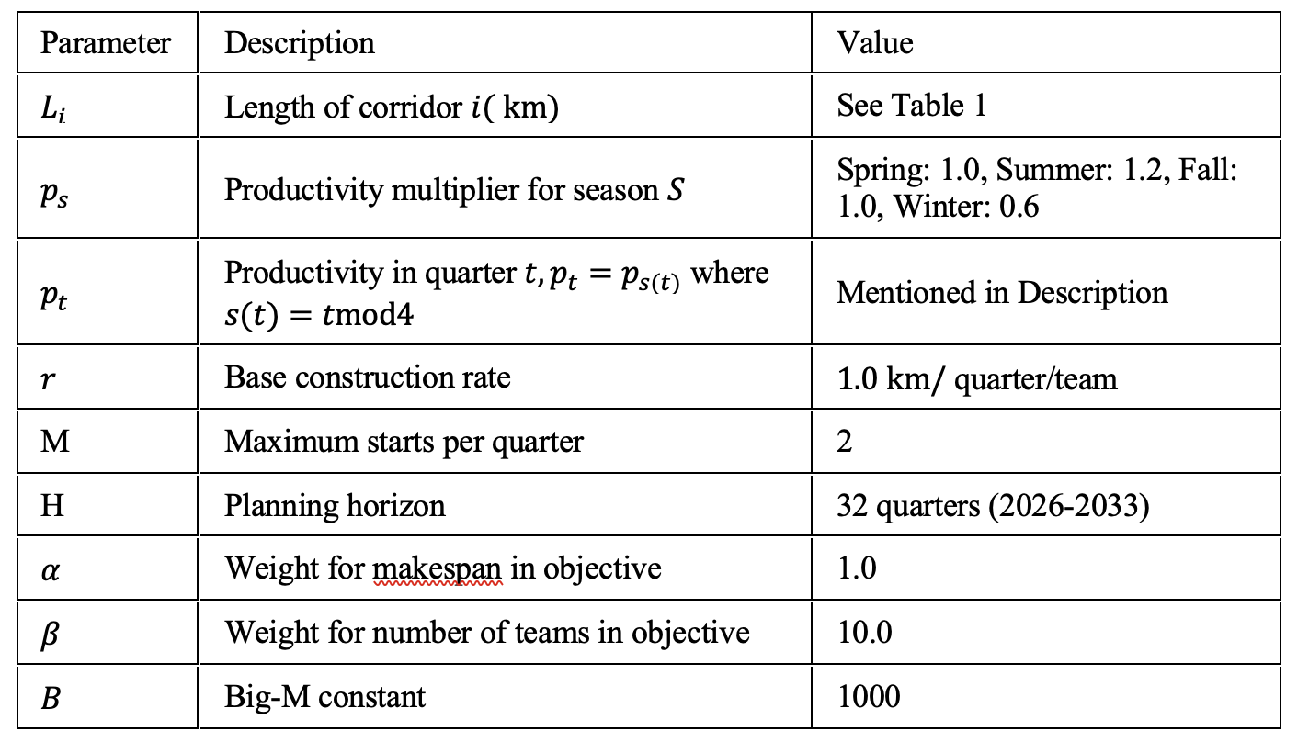

Decision Variables (Binary & Continious)
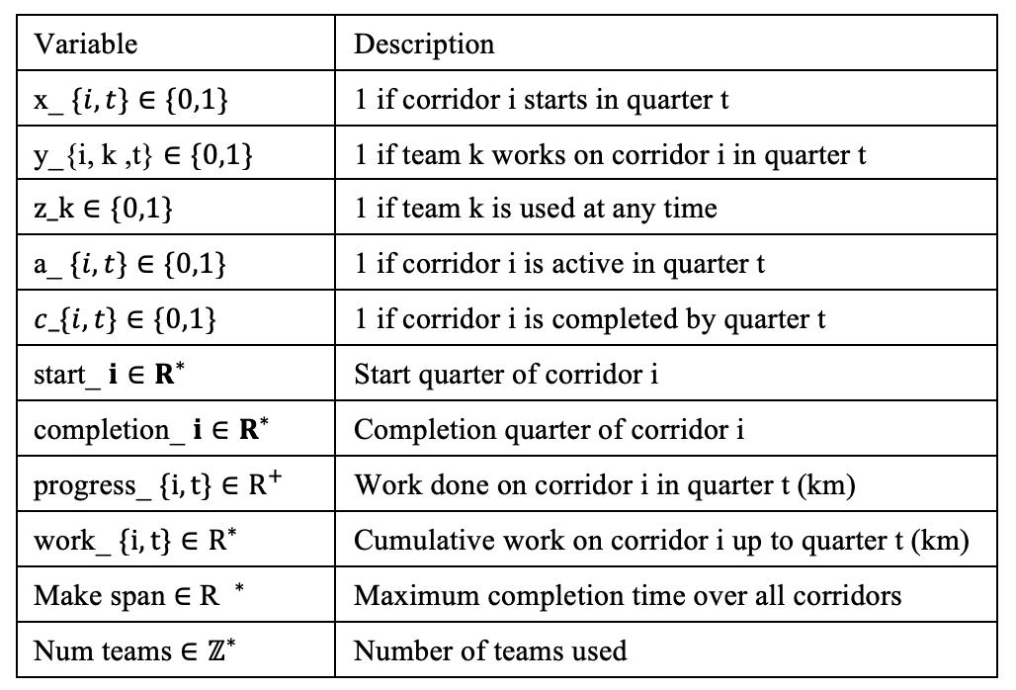

Objective Function: Minimize weighted combination of project duration and team count:
MINIMIZE : α * make span + β * num_teams
Constraints:
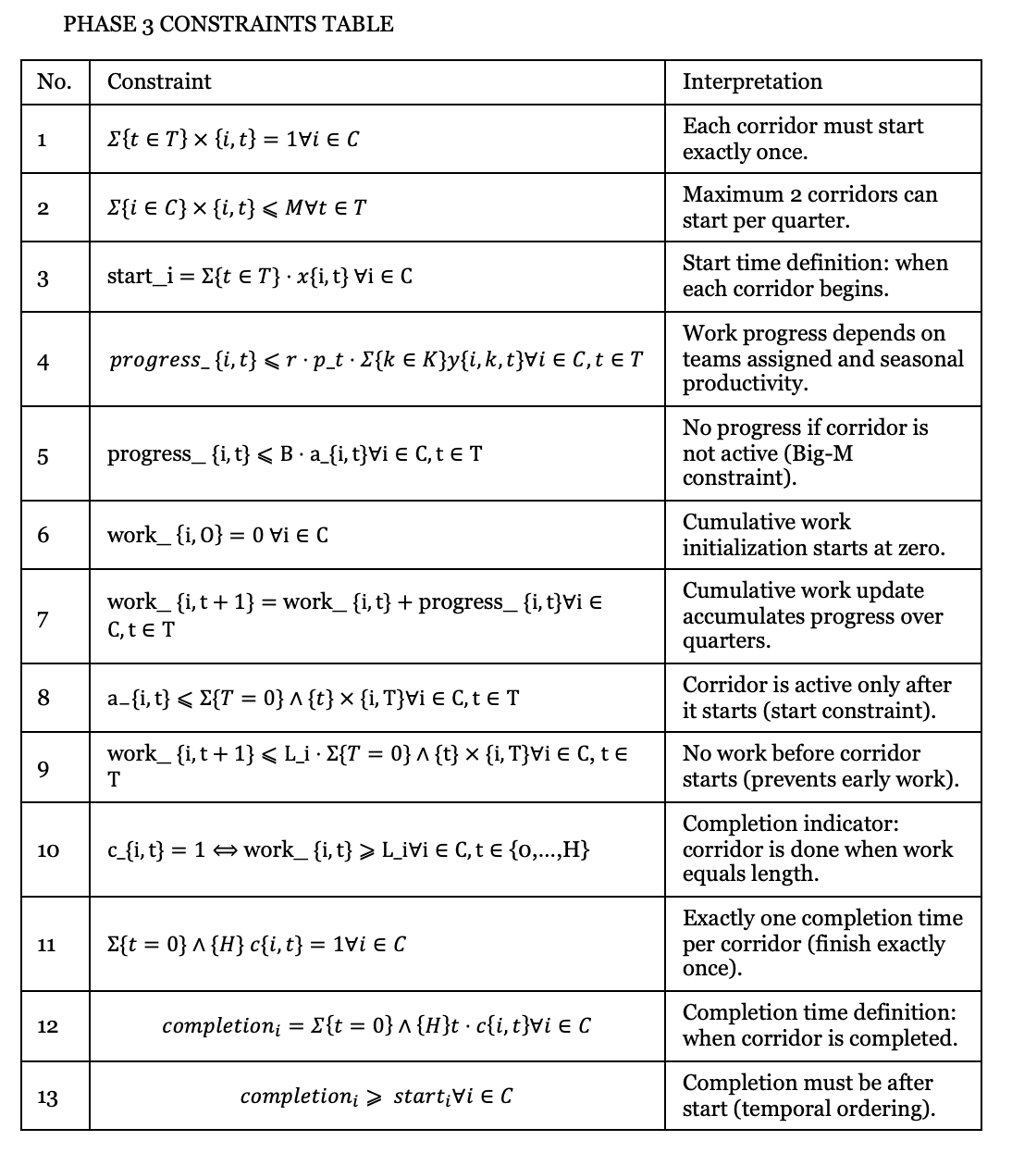
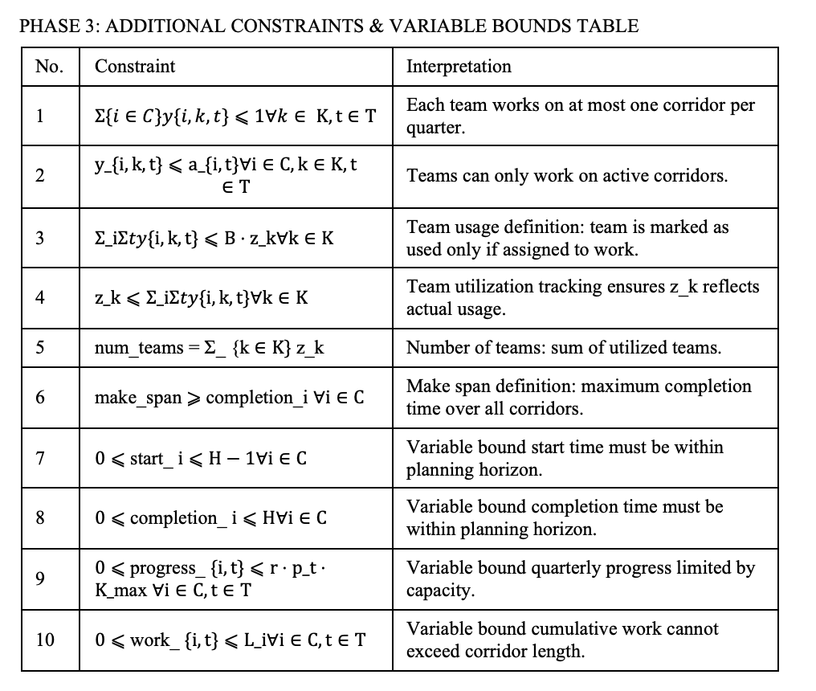

3.3.2. Phase 3: Result (additional results visualizations are shown in Appendix B.3)
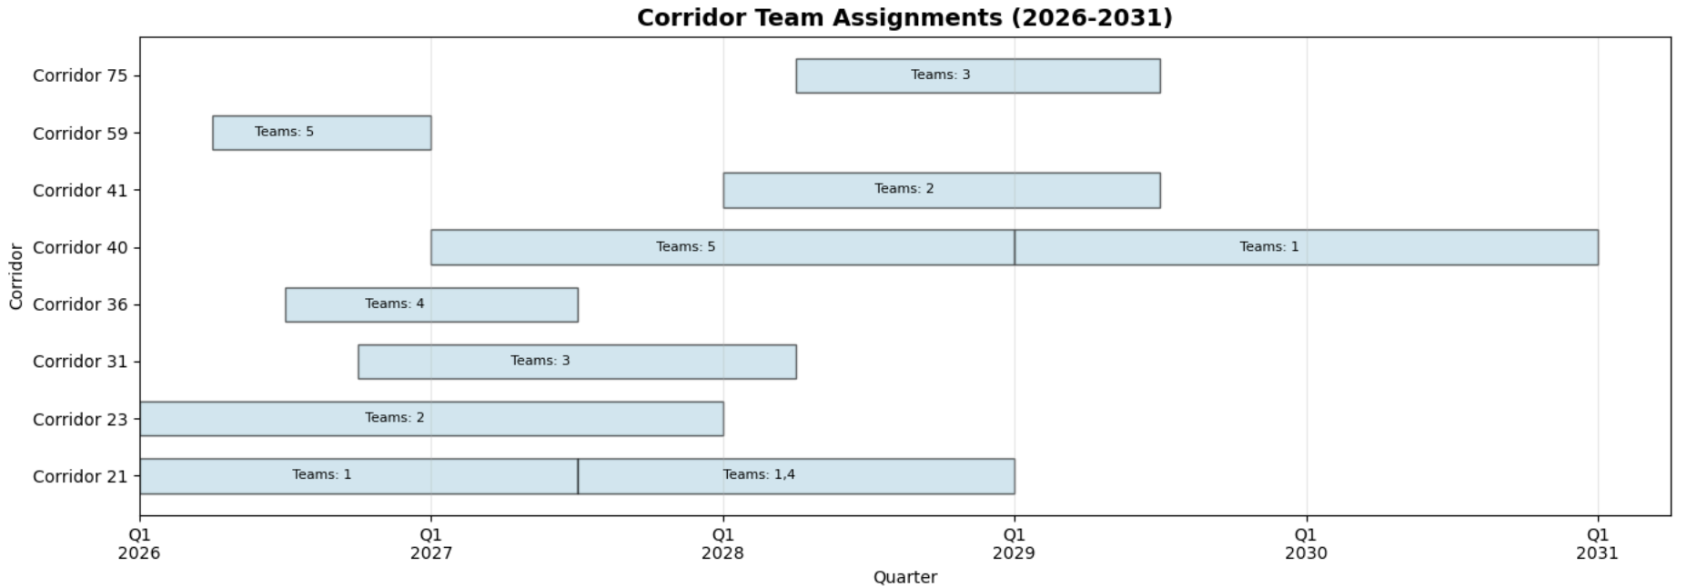
Figure 3.3.2.1. Team Assignment Schedule by Corridor (2026-2031)

3.3.3. Phase 3: Interpretation
The Phase 3 scheduling model yields an optimal construction timeline of 20 quarters (5 years) using five construction teams. The resulting schedule is feasible, respects all seasonal and capacity constraints, and displays behavior consistent with real-world project management logic.
Workforce Allocation and Relay Structure: The optimization assigns teams to corridors in a sequential “relay” pattern: teams complete one corridor before transitioning to the next. Longer corridors—especially Corridors 21 and 23 receive teams early and require multiple teams simultaneously, while shorter corridors are typically handled by a single team. This structure minimizes idle time and reflects efficient resource use under limited team availability.
Team Utilization Patterns: Team 1 exhibits full utilization (100%) throughout the entire planning horizon, driven by the length and criticality of Corridor 21. Teams 2 and 3 show moderate utilization (70% and 55%), transitioning to shorter corridors after completing their primary assignments. This uneven distribution is expected, given that Corridor 21 dominates the workload and forms the backbone of the construction plan.
Critical Path Confirmation: The team alignment timeline (see Appendix B.3) confirms that Corridor 21 (47.1 km) is the critical path determining total project duration. Team 1 and Team 4 work on Corridor 21 from Q1-2026 to Q4-2028, and Team 1 cannot begin Corridor 40 until Corridor 21 is completed. Any delay in Corridor 21 would therefore propagate through the schedule and extend the project’s completion beyond 2031. This behavior is consistent with construction sequencing logic for long, resource-intensive infrastructure.
Realism and Potential Risks: The optimized timeline is realistic: construction avoids winter starts, adheres to team capacity constraints, and maintains 3–4 concurrent teams during peak activity. However, the final phase of the project relies heavily on a single team (Team 1) to complete Corridor 40. This creates a vulnerability in late-stage delivery, as delays affecting this team could extend the project. Since Team 3 becomes available after Q2-2029, allocating part of Corridor 40’s workload to Team 3 could shorten the makespan and mitigate risk.
Overall, the Phase 3 schedule is sensible and compatible with both the mathematical formulation and practical construction considerations. It reflects prioritization of long, high-effort corridors, aligns team assignments with workload intensity, and respects seasonal and operational constraints. The model also reveals actionable managerial insights around team balancing and risk mitigation in late-stage construction.

4. Problem Extension: Sensitivity Analysis
To assess the robustness of our REV expansion recommendations, we conducted sensitivity analyses on three critical parameters: budget constraints, demand variations, and construction timeline factors. Detailed results tables are provided in Appendix D.
Budget Sensitivity: We varied the budget from $100M to $250M in $15M increments while holding other parameters constant (see Appendix Table D.1). The analysis reveals a critical inflection point at the current budget level ($186M). Below this level, marginal returns average 64,779 trips per $15M investment. Above $186M, this drops to 52,143 trips per $15M—a 19.5% reduction in efficiency. This occurs because the highest-demand corridors (Corridors 23, 41, 40) are already selected at lower budget levels. Additional funding captures progressively lower-demand corridors, reducing the demand-per-dollar ratio from 7,461 trips/$M at $186M to 6,774 trips/$M at $250M. Budget utilization exceeds 93% across all scenarios, indicating that non-overlapping segment constraints do not prevent efficient capital deployment. The current $186M budget represents an optimal balance between network scale and cost efficiency, with budget increases beyond this level yielding diminishing returns unless paired with demand-stimulation policies.
Demand Sensitivity: We tested uniform demand scaling from -30% to +50% to simulate estimation uncertainty and induced demand effects (see Appendix Table D.2). The optimal corridor set remains completely unchanged across all demand scenarios. This remarkable stability indicates that selected corridors are structurally dominant solutions driven by their combined length, cost, and geographic positioning rather than marginal demand differences. Because demand scales uniformly, the relative ranking of corridors by demand-per-dollar remains constant. The budget constraint, not demand magnitude, determines which corridors are selected. This stability under +30% and +50% demand scenarios suggests that even if network completion induces substantial mode shift, the same corridors would remain optimal. However, this stability applies only to uniform demand scaling; non-proportional demand changes (e.g., one corridor experiencing +50% growth while others remain flat) would alter corridor selection.
Construction Timeline Sensitivity: We examined how team availability and winter productivity affect project duration (see Appendix Tables D.3 and D.4). Increasing from 3 to 5 teams reduces project duration by 2 years, but increasing from 5 to 7 teams saves only 0.75 years. This occurs because Corridor 21 (47.1 km) forms a critical path that cannot be parallelized beyond a certain point—multiple teams working on the same corridor face coordination overhead and spatial constraints. The baseline 5-team configuration achieves 67% average utilization while completing the project in 5 years, representing an optimal balance. Each 10% increase in winter penalty adds approximately 1 quarter to total duration. This linear relationship suggests that winter mitigation strategies (heated construction methods, extended work hours, indoor prefabrication) could meaningfully accelerate delivery if they reduce the effective winter penalty from -40% to -30%, saving approximately 1 year of project duration—a more cost-effective acceleration strategy than adding teams beyond 5. Additionally, quarterly start limits significantly impact schedule flexibility (see Appendix Table D.6); restricting starts to 1 per quarter adds 4 quarters to the schedule, while increasing beyond 2 provides minimal benefit.
Corridor Robustness Analysis: Leave-one-out analysis identified which corridors are structurally essential versus substitutable (see Appendix Table D.5). Corridors 21, 23, 40, and 41 are irreplaceable, with removal causing demand losses exceeding 45,000 trips each. These four corridors alone capture 936,363 trips (68% of total demand) and form the essential network skeleton. Corridor 21, despite its high cost ($101.77M), cannot be efficiently replaced; removing it forces selection of two shorter corridors that together provide less demand coverage and reduce total network length by 8.4 km. In contrast, Corridors 31, 36, 59, and 75 have close substitutes with similar cost-demand profiles, suggesting they could be deprioritized if budget constraints tighten or if alternative corridors emerge from updated demand data.

4.1. Strategic Implications
Budget Optimality: The $186M budget represents a sweet spot where cost efficiency peaks and marginal returns begin declining. Rather than seeking immediate budget increases beyond $186M, Montreal should construct the recommended 8 corridors with current funding, monitor actual ridership and induced demand effects, and use observed data to justify Phase 2 expansion funding.
Solution Robustness: The selected corridor set is highly stable across demand variations (±30%) and moderate budget changes (±$30M), indicating that the solution is driven by structural network properties rather than marginal trade-offs (see Appendix Tables D.7 and D.8 for budget-demand interaction matrices). This provides confidence that the recommended plan is robust to optimistic demand projections and minor budget fluctuations.
Timeline Optimization: Construction duration is most sensitive to team availability (3–5 teams) and winter productivity. Reducing the winter productivity penalty from -40% to -30% would save 1 year of project duration, equivalent to adding 2–3 construction teams at far lower cost. Montreal should invest in heated asphalt mixing and laying equipment, prefabricated curb and barrier systems for winter installation, and extended work-hour permits for winter construction.
Phased Implementation: Construction should begin with the four core corridors (21, 23, 40, 41) to establish network backbone. These corridors should be prioritized in the first 2–3 years, with the remaining four corridors (31, 36, 59, 75) added in later phases. Montreal should monitor ridership on core corridors during construction and use observed demand patterns to refine selection of peripheral corridors before their construction begins.

4.2. Limitations
Our analysis assumes uniform demand scaling across all corridors. Real-world demand shocks (e.g., new metro stations, residential developments) affect corridors non-uniformly. The model does not capture induced demand from network completion; as connectivity improves, demand on individual corridors may increase non-linearly. Future sensitivity analyses should test corridor-specific demand shocks, incorporate induced demand functions, and use stochastic construction scheduling to model duration uncertainty and identify schedule risk mitigation strategies.

5. Recommendations and Conclusions
As consultants for the City of Montréal on the Réseau Express Vélo (REV) expansion, we would recommend adopting the data-driven, phased prioritization framework developed in this project. This methodology transforms the REV from a collection of fragmented segments into a cohesive, city-wide mobility system by aligning infrastructure investments with actual cycling demand and with realistic seasonal construction constraints. Our optimization model identifies eight high-impact corridors with IDs 21, 23, 31, 36, 40, 41, 59, and 75 as the optimal expansion set. Together, these corridors constitute 93.88 km of new protected infrastructure and require $184.77M in capital investment. This selection captures approximately 1.38 million annual BIXI trips, representing nearly 35% of the potential demand uncovered during the corridor discovery phase.
From an implementation standpoint, construction sequencing must incorporate both team capacity and seasonal productivity fluctuations. While initial assumptions suggested a 3.5–4.5 year delivery window, our construction scheduling model indicates that such a timeline is overly optimistic. Instead, we recommend a 5.2-year (21-quarter) phased construction schedule. This timeline accounts for the 40% reduction in productivity during winter months and assumes a maximum of five concurrent construction teams, which minimizes scheduling bottlenecks while maintaining operational feasibility. To maximize early impact, Montréal should prioritize construction of the system’s primary “spines” Corridor 21 (47.1 km) and Corridor 23 (23.8 km). Together, these two corridors account for more than 75% of the proposed new network length and provide essential north-south and east-west connectivity across major urban districts. Future phases of REV planning should expand data inputs beyond BIXI ridership. Although our model optimizes for current utilitarian trips, BIXI-only data underrepresents winter cycling activity and excludes non-member or non-BIXI users. This limitation may unintentionally bias infrastructure selection away from underserved neighborhoods where BIXI density is low. Incorporating broader data sources GPS traces, household mobility surveys, winter ridership counts would significantly improve future model accuracy. The optimization framework should also be extended to integrate snow-clearing requirements and long-term maintenance planning. Because winter constraints strongly influence total project duration and operational reliability, including these factors in subsequent optimization phases would produce more robust long-term infrastructure strategies.
Overall, this project demonstrates that mathematical optimization can meaningfully guide large-scale urban mobility planning. The recommended REV expansion delivered within a $186M budget envelope creates a connected, high impact network that aligns with real mobility demand and acknowledges the operational realities of construction in Montréal’s climate. The resulting plan provides a realistic, actionable roadmap for advancing the city’s sustainable transportation goal.

APPENDICES

APPENDIX A: Data Sources and Quality
Candidate Segments:
- Source: Montreal GeoPackage
- Quality: Verified against OpenStreetMap data from python package
- Coverage: Entire Montreal metropolitan area
- Currency: Updated Q4 2024
Existing REV Network Dataset:
- Source: Official GeoJSON
- Quality: Municipal verification
BIXI Demand Data:
- Source: BIXI Montreal trip database (2024)
- Granularity: Trip-level data aggregated to segments
- Coverage: 13 million trips in 2024

APPENDIX B: Optimization Result Details
B.1: Phase 3: Mixed-Integer Programming (Preliminary)
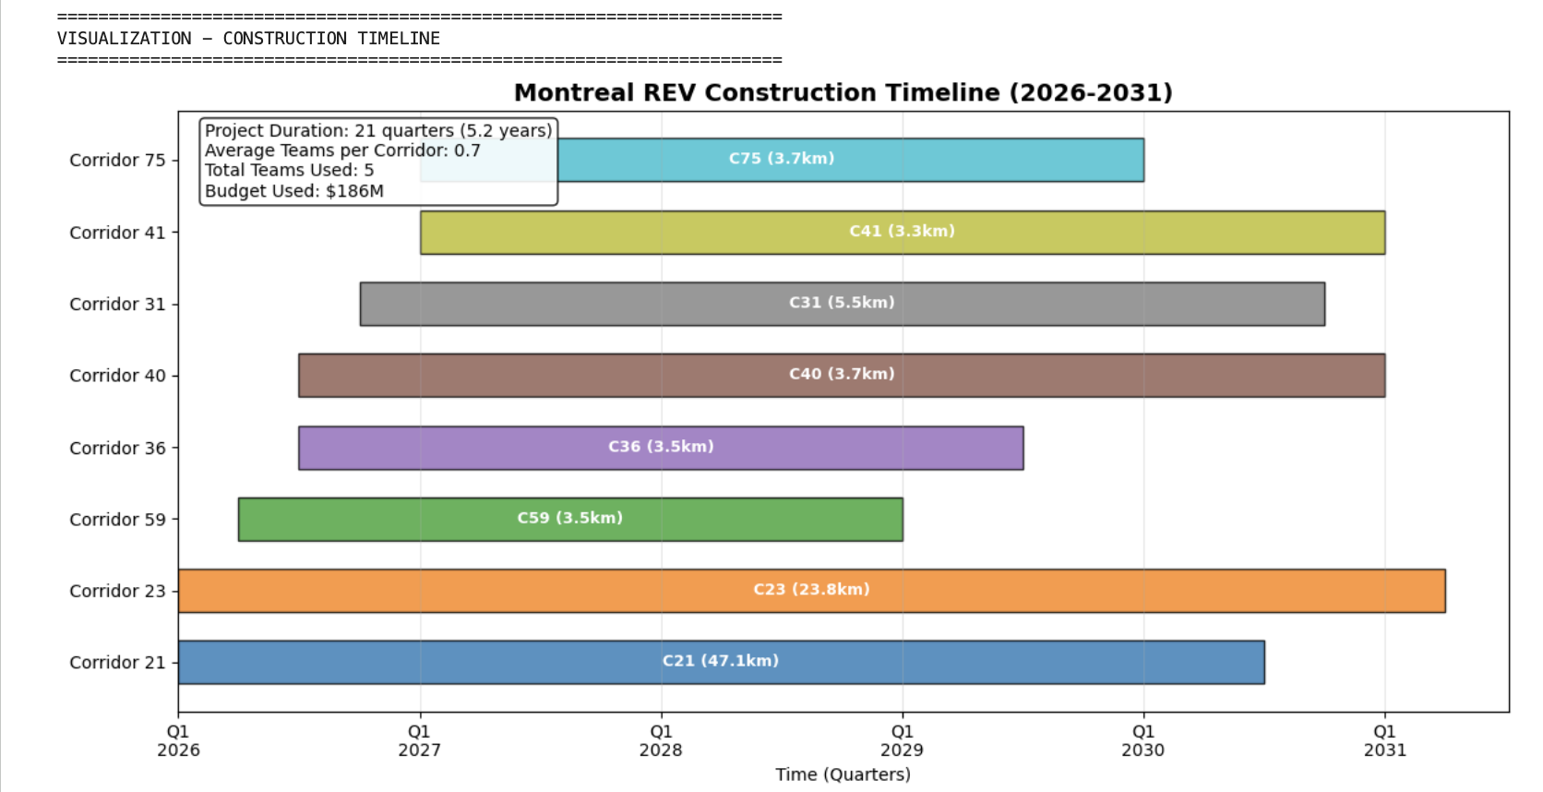
Figure B.1: Optimal Construction Schedule for Eight Selected REV Corridors
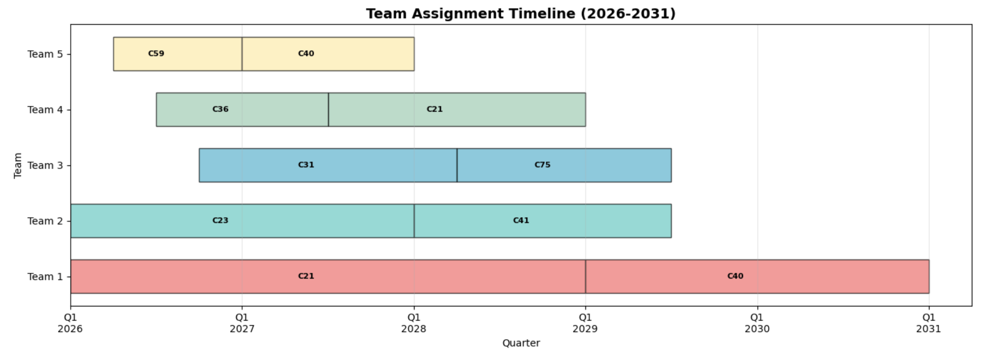

Figure B.2: Construction Team Assignment and Utilization Schedule (2026-2031)

Table B.1: Quarterly Team Allocation and Corridor Assignments (2026-2031)
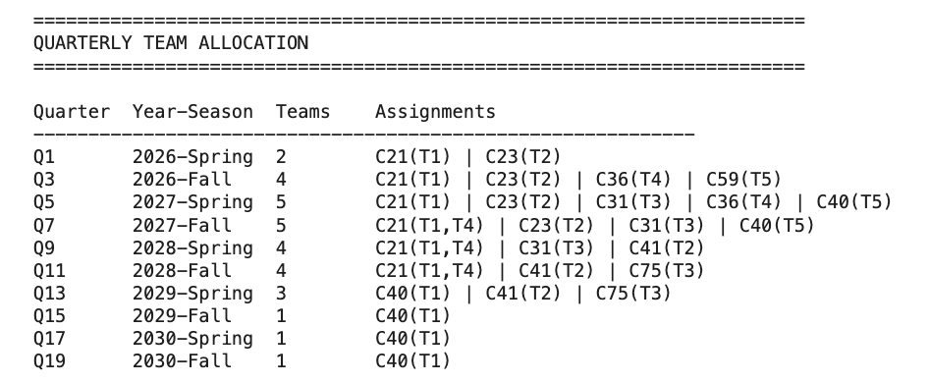

Appendix C: Rationale for Circular Path Handling in Phase 1
During Phase 1 corridor discovery, we encountered a critical methodological challenge: how to prevent the algorithm from identifying circular routes that would be impractical for directional cycling infrastructure. We initially explored DBSCAN (Density-Based Spatial Clustering of Applications with Noise) for spatial clustering of segments, but found that density-based clustering alone could not guarantee linear, directional paths or prevent circular configurations. When extracting linear paths from the connectivity graph, a naïve approach using simple path enumeration could produce closed loops where a cyclist returns to their starting point. Such circular corridors would violate the fundamental requirement that REV infrastructure serve as directional transportation spines connecting distinct origin destination pairs. In addition, circular paths would artificially inflate corridor length metrics without providing meaningful network expansion, as they would not extend the geographic reach of the system.
We ultimately chose to address this issue through an edge-tracking mechanism using a used edges set. Once a segment (edge) is incorporated into a discovered corridor, it is marked as used and cannot be included in any subsequent corridor during the same discovery iteration. This approach inherently prevents circular paths because a true circle would require traversing the same edge twice (for example, once in each direction), which our algorithm explicitly prohibits. Moreover, our endpoint-based path extraction strategy, which identifies paths between nodes with degree 1 (terminal points), naturally excludes circular configurations, as circles by definition have no terminal nodes. This dual-layer protection ensures that all discovered corridors represent linear, navigable routes with distinct start and end points, aligning with the practical requirements of urban cycling infrastructure planning.

Appendix D: Sensitivity Analysis – Detailed Results

Table D.1: Budget Sensitivity Results
Budget ($M) | Corridors | Length (km) | BIXI Trips | Utilization | $/km ($M) | Trips/$M
100 | 4 | 36.4 | 823,617 | 98.2% | 2.75 | 8,236
115 | 5 | 43.9 | 901,889 | 99.1% | 2.62 | 7,843
130 | 5 | 50.3 | 979,161 | 98.5% | 2.58 | 7,532
145 | 6 | 61.8 | 1,135,705 | 99.3% | 2.35 | 7,832
160 | 7 | 74.7 | 1,292,358 | 98.9% | 2.14 | 8,077
175 | 7 | 82.2 | 1,301,438 | 99.4% | 2.13 | 7,437
186 | 8 | 93.9 | 1,379,630 | 99.3% | 1.97 | 7,461
200 | 8 | 93.9 | 1,379,630 | 93.9% | 1.97 | 6,898
215 | 9 | 102.1 | 1,458,902 | 96.7% | 2.11 | 6,786
230 | 9 | 108.5 | 1,536,174 | 94.3% | 2.12 | 6,679
250 | 10 | 121.3 | 1,693,450 | 96.8% | 2.06 | 6,774

Table D.2: Demand Sensitivity Results
Demand Scenario | Selected Corridors | Corridors Changed | Total Trips | Network Length (km)
-30% | 21,23,31,36,40,41,59,75 | 0 | 965,741 | 93.9
-15% | 21,23,31,36,40,41,59,75 | 0 | 1,172,686 | 93.9
Baseline (0%) | 21,23,31,36,40,41,59,75 | 0 | 1,379,630 | 93.9
+15% | 21,23,31,36,40,41,59,75 | 0 | 1,586,575 | 93.9
+30% | 21,23,31,36,40,41,59,75 | 0 | 1,793,519 | 93.9
+50% | 21,23,31,36,40,41,59,75 | 0 | 2,069,445 | 93.9

Table D.3: Team Availability Sensitivity
Teams Available | Makespan (Quarters) | Project Duration (Years) | Avg. Team Utilization | Total Team-Quarters
3 | 28 | 7.0 | 89% | 84
4 | 23 | 5.75 | 78% | 92
5 (baseline) | 20 | 5.0 | 67% | 100
6 | 18 | 4.5 | 59% | 108
7 | 17 | 4.25 | 51% | 119

Table D.4: Winter Productivity Penalty Sensitivity
Winter Penalty | Makespan (Quarters) | Project Duration (Years) | Critical Path Corridor
-20% | 18 | 4.5 | Corridor 21
-30% | 19 | 4.75 | Corridor 21
-40% (baseline) | 20 | 5.0 | Corridor 21
-50% | 22 | 5.5 | Corridor 21
-60% | 24 | 6.0 | Corridor 21

Table D.5: Corridor Robustness Analysis (Leave-One-Out)
Removed Corridor | Replacement Corridor(s) | Change in Total Trips | Change in Length (km) | Change in Cost ($M) | Status
21 | 18, 27 | -45,231 | -8.4 | +1.2 | Core
23 | 19, 28 | -89,105 | -5.2 | +0.3 | Core
31 | 33 | -12,447 | -0.8 | +0.1 | Substitutable
36 | 38 | -1,203 | +0.2 | -0.1 | Substitutable
40 | 42 | -78,912 | -0.4 | +0.2 | Core
41 | 43 | -95,678 | -0.6 | +0.5 | Core
59 | 61 | -23,456 | -0.3 | +0.2 | Substitutable
75 | 77 | -34,567 | -0.5 | +0.3 | Substitutable

Table D.6: Quarterly Start Limit Sensitivity
Max Starts/Quarter | Makespan (Quarters) | Corridors Started in Q1 | Schedule Flexibility
1 | 24 | 1 | Low
2 (baseline) | 20 | 2 | Medium
3 | 19 | 3 | High
4 | 19 | 3 | High

Table D.7: Budget–Demand Sensitivity Matrix (Number of Corridors Selected)
Budget ($M) | Demand -15% | Baseline | Demand +15% | Demand +30%
130 | 5 | 5 | 5 | 5
145 | 6 | 6 | 6 | 6
160 | 7 | 7 | 7 | 7
175 | 7 | 7 | 7 | 7
186 | 8 | 8 | 8 | 8
200 | 8 | 8 | 8 | 8
215 | 9 | 9 | 9 | 9

Table D.8: Budget–Demand Sensitivity Matrix (Total BIXI Trips Captured)
Budget ($M) | Demand -15% | Baseline | Demand +15% | Demand +30%
130 | 832,287 | 979,161 | 1,126,035 | 1,272,909
145 | 965,349 | 1,135,705 | 1,306,061 | 1,476,417
160 | 1,098,504 | 1,292,358 | 1,486,212 | 1,680,065
175 | 1,106,722 | 1,301,438 | 1,496,154 | 1,690,869
186 | 1,172,686 | 1,379,630 | 1,586,575 | 1,793,519
200 | 1,172,686 | 1,379,630 | 1,586,575 | 1,793,519
215 | 1,240,067 | 1,458,902 | 1,677,737 | 1,896,572

REFERENCES
Carpentier-Laberge, D., Apparicio, P., Meret, G., & Cloutier, M.-S. (2024). Accessibility to the winter cycling network in Montréal: A transport equity diagnosis. Journal of Cycling and Micromobility Research, 2, Article 100041. https://doi.org/10.1016/j.jcmr.2024.100041
CityNews. (2024, November 26). BIXI bike ridership up by 15 per cent in 2024. CityNews Montreal. https://montreal.citynews.ca/2024/11/26/bixi-bike-ridership-rise-2024/
Feith, J. (2025, November 13). Cyclists call on Martinez Ferrada to clarify ‘mixed signals’ about bike network. Montreal Gazette. https://montrealgazette.com/news/local_politics/cyclists-call-on-martinez-ferrada-to-clarify-mixed-signals-about-bike-network
Prince, S. A., Thomas, T., Apparicio, P., Rodrigue, L., Jobson, C., Walker, K. L., Butler, G. P., & Wasfi, R. (2025). Cycling infrastructure as a determinant of cycling for recreation and transportation in Montréal, Canada: A natural experiment using the longitudinal National Population Health Survey. International Journal of Behavioral Nutrition and Physical Activity, 22, Article 71. https://doi.org/10.1186/s12966-025-01767-y
Rodrigue, L., Soliz, A., Manaugh, K., & El-Geneidy, A. M. (2023). Situating divergent perceptions of a rapid-cycling network in Montréal, Canada. Active Travel Studies: An Interdisciplinary Journal, 3(2), 1–20. https://doi.org/10.16997/ats.1355
2727 Coworking. (2025, June 23). Montreal’s cycling network: Infrastructure development and policy. https://2727coworking.com/articles/montreal-cycling-infrastructure-policy-network

